**Learners have to come up with a dashboard in order to support the answers to the following questions and suggestions for places for newer restaurants.**

**Objective Questions**:

1. The data consists of some inconsistent and missing values so ensure that the data used for further analysis is cleaned.
   * 1. Removed all the restaurants which did not have any votes because a restaurant without votes mean that there is very less people going to those restaurants and that will not affect the analysis.
     2. Created a column to calculate average cost for two in dollars as the given data only contains average cost for two in their country’s value.
     3. Created a column to calculate the date of opening from the “datekey_opening” column.
2. Using the LookUp functions, fill up the countries in the original data using the country code.

Answer: =VLOOKUP($C2, 'country description'!$A$1:$B$16, 2)

1. Create a table to represent the number of restaurants opened in each country.

Visualization:

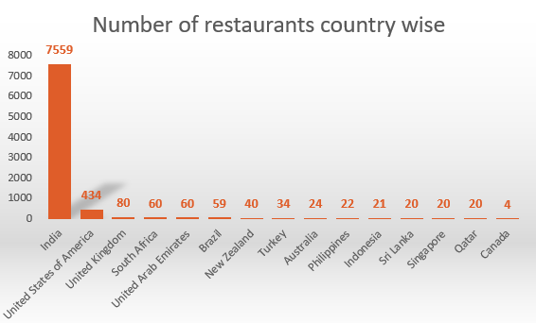 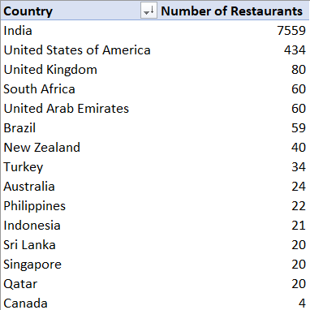

**Observation:**

* According to the data, **India** has the highest number of restaurants with the count of **7559** and followed by **USA** with **434** restaurants.
* **Canada** has the least number of restaurants with **4** as the count.

1. Also, the management wants to look at the number of restaurants opened in each year, so provide them with something here.

**Visualization:**

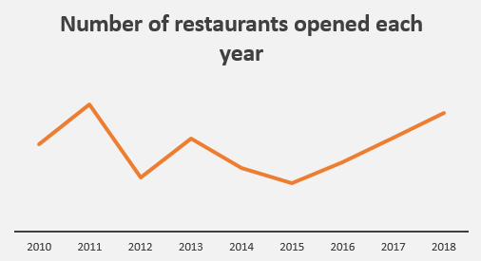 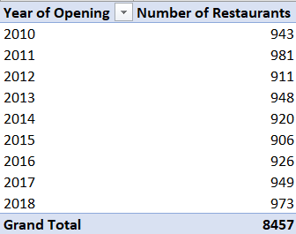

**Observation:**

* + 1. The **highest** number of restaurants were opened in the year **2011** (**981** restaurants) and the **least** number of restaurants were opened in the year **2015**(**906** restaurants).
    2. There was a dip in 2012 where the number of restaurants opened decreased exponentially.
    3. Ever since there has been a steady growth in the number of restaurants opened every year.

1. What is the total number of restaurants in India which are in the price range of 4?

Formula: =COUNTIFS('Raw Data'!D:D, "India", 'Raw Data'!Q:Q, "4")



1. According to the data, what is the average number of voters for the restaurants in each country?

**Visualization:**

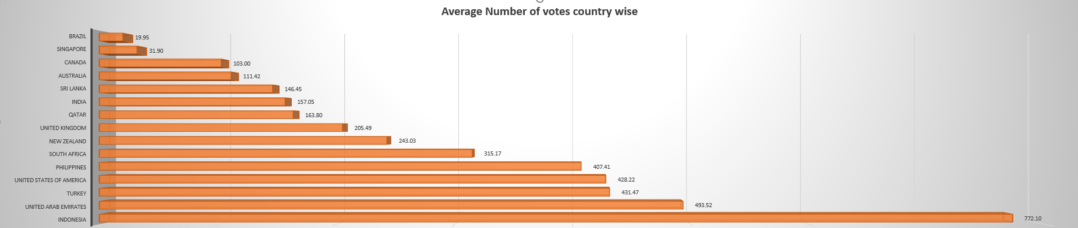

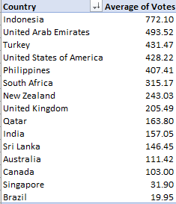

**Observation:**

* + 1. **Indonesia** has the **highest** average for votes whereas **Brazil** has the **least** average votes.
    2. Even though India has highest number of restaurants opened over the years, it’s average votes looks in the mid-way. This could mean something which should be considered while opening a restaurant.

**Subjective Question:**

1. Suggest a few countries where the team can open newer restaurants with lesser competition. Which visualization/technique will you use here to justify the suggestions?

**Visualization:**

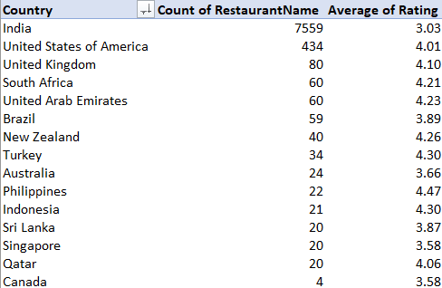 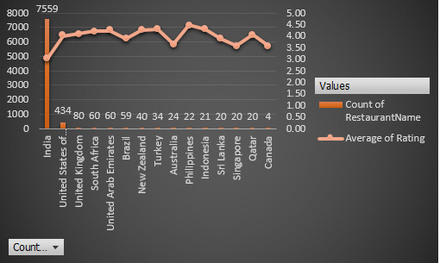

**Insights:**

* It is evident that in the below countries the competition is less and also the average rating is less. So if the business decides to start a restaurant in the mentioned countries it is likely to gain success. Below are the country names:
  + 1. Canada
    2. Qatar
    3. Singapore
    4. Sri Lanka
    5. Australia
    6. India.
* Even though India has the most number of restaurants, the average rating for those restaurants barely crosses 3 rating.

**Recommendations:**

* Running a quality restaurant with quality food in India will gain a good rating from the customers.
* In other mentioned countries the number of restaurants available is very less which is good sign for the management to decide according to the business needs. Regardless of the above places, the business will be a success if they can provide quality food.

1. Come up with the names of States and cities in the suggested countries suitable for opening restaurants.

**Visualization:**

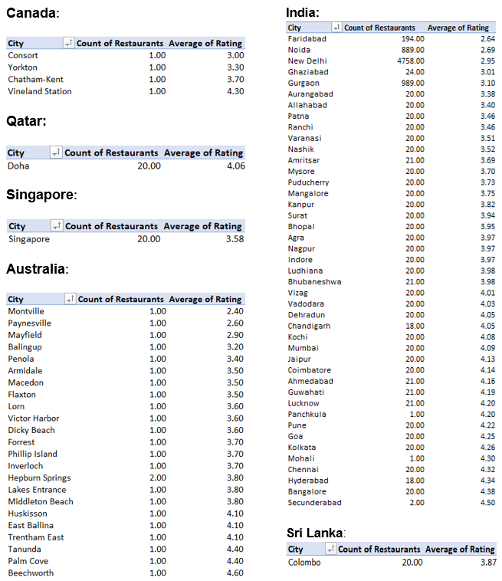

**Insights:**

Considering only the cities where there are less than 10 restaurants and average rating less than or equal to 3 we find out the least competing cities where a new restaurant can be opened.

**Recommendations:**

* After filtering the data, the cities in which the restaurant could be opened are:
  + 1. Consort (Canada)
    2. Singapore (Singapore)
    3. Mayfield, Montville, Balingup, Paynesville (Australia)
    4. Nagpur, Nashik, Jaipur, Indore, Puducherry, Patna, Aurangabad, Varanasi, Ranchi, Allahabad (India)
    5. Colombo (Sri Lanka)
    6. Doha (Qatar)

1. According to the countries you suggested, what is the current quality regarding ratings for restaurants that are open there?

**Visualization:**

Refer 2nd question visual.

**Inference:**

* Average of ratings for the suggested cities lie between 2 and 5. Displaying the count of cities which fall under each range.
  + 1. 2 – 3: 6 cities
    2. 3 – 4: 39 cities
    3. 4 – 5: 27 cities
* **Montville** has the least average rating of **2.40**
* **Beechworth** has the highest average rating of **4.60**
* Restaurant’s average rating in most of the cities lie between 2 and 3.

**Recommendation:**

* Looking at the average ratings of all the cities, recommendation to the management is to start a new restaurant in the cities which have an average rating between 2-3.
* This will ensure that the newly opened restaurant sees a quick success and captures more customers.

1. Also, what is the current expenditure on food in the suggested countries, so we can keep our financial expenditure in control?

**Visualization:**

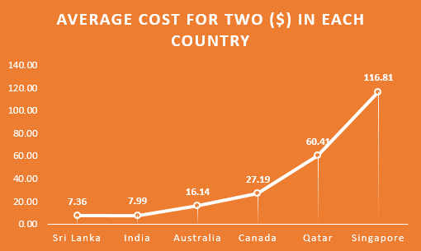

**Inference:**

* **Least** average cost for two people is in **Sri Lanka** with costing **7.36** US dollars.
* **Highest** average cost for two people in **Singapore** with costing **116.81** US dollars respectively.

**Recommendation:**

* From the chart we can recommend the business to open a restaurant either in Sri Lanka or in India as the average cost for two is less than 10 dollars.
* Considering all the factors such as groceries and rent, it is less expensive for the business and will help in generating more profits.

1. Come up with the names of restaurants from the recommended states that are our biggest competitors and also those that are rated in the lower brackets, i.e. 1-2 or 2-3.

**Visualization 1:**

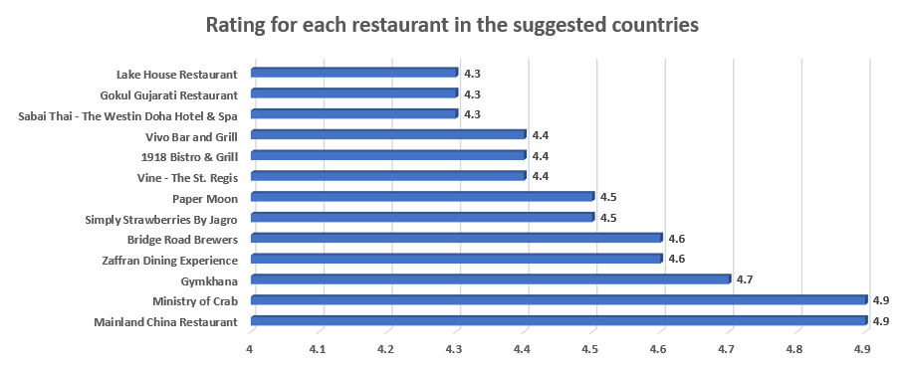

**Visualization 2:**

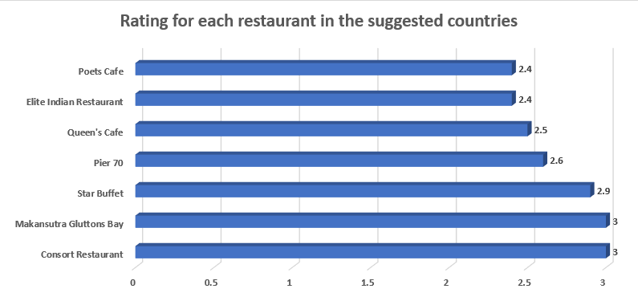

**Insights:**

* “Visualization 1” represents the biggest competitors for the management in **Australia, Canada, Singapore, Sri Lanka and Qatar**.
* Considering the restaurants **above 4.5** rating as the competitors, there are **13 restaurants** which could possibly be the competitors.
* “Visualization 2” represents the restaurants which come under lower bracket (1-2, 2-3) and there are totally **7 restaurants** in the suggested countries.

1. Which cuisines should we focus on in the newer restaurants to get better feedback? Does the choice of cuisines affect the restaurant ratings?

**Visualization:**

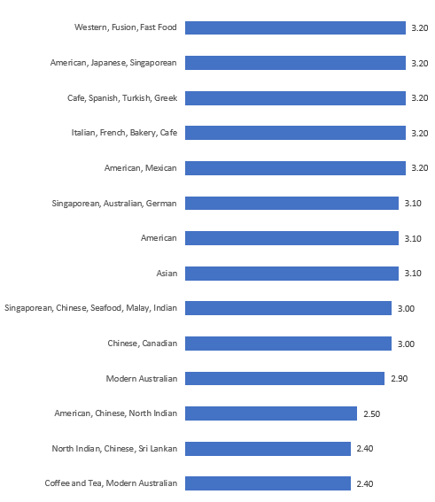

**Inference:**

* Considering the **10 least rated cuisines**, the least rated cuisine among them is “**Coffee and Tea, Modern Australian**” with a rating of **2.40** and the cuisine “**Western, Fusion, Fast Food**” is with a rating of **3.20**.

**Recommendation:**

* These are the cuisines that a newly opening restaurant should concentrate more to gain better feedback when compared to others.
* If a newly opening restaurant is to concentrate more on other cuisines it is hard to gain a better feedback as they already have a better rating.

1. According to our current data, should we go for online delivery and table booking? Does that affect the customer’s ratings?

**Visualisation:**

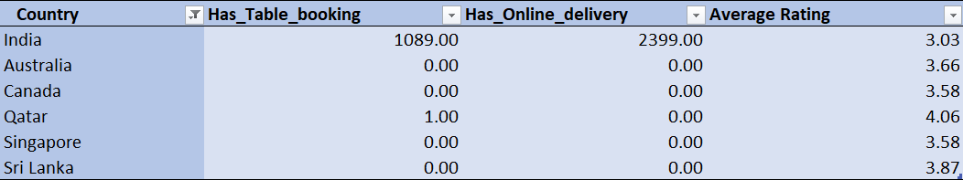

**Inference:**

* According to the data, there are only restaurants in India with the option to **book the table** or **order online** with the count of **1089** and **2399** restaurants respectively.
* Many restaurants outside India haven’t opted to table booking and online delivery yet.
* So this will not affect the ratings of the restaurants outside India.

**Recommendation:**

* If we are going to start a new restaurant inside India, to be successful, the management has to opt in for table booking and should have an option for online delivery.
* But if the management decides to open a restaurant outside of India, dine-in should be fine as there is no competition for online delivery and table booking.

1. Should the team keep the rate of cuisines higher? Will that affect the feedback? According to our data are the rates of cuisines and ratings, correlated?

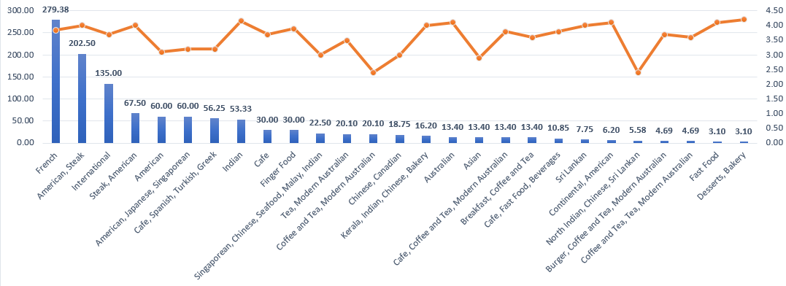

**Insights:**

* According to the given data, it is evident that the rating and rates of cuisines are not correlated.
* A cuisine with average cost of $60 has the same rating as when compared with a cuisine that has an average cost of $22.5

**Recommendation:**

* The rate of cuisine does not necessarily be higher. It is better to consider the cuisines which can be costed at a medium cost.